**R Code for Examples in the book**

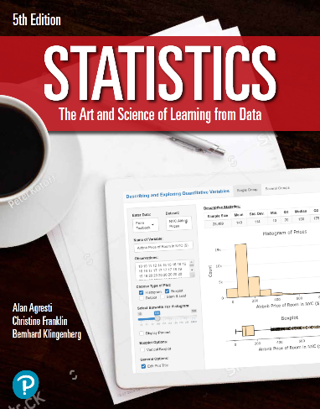

***“Statistics: The Art and Science of Learning from Data”***

**by Agresti, Franklin and Klingenberg, 5th edition**

**Chapter 8**

**Example 3: Constructing and Interpreting a Confidence Interval**

## Reading in sample proportion data

x <- 637  
n <- 1361  
phat <- x / n

## To compute the standard error

se <- sqrt(phat * (1 - phat) / n)  
se

## [1] 0.01352545

## To compute the margin of error for a confidence level of 95%

zscore <- qnorm(0.975)  
me <- zscore * se  
me

## [1] 0.0265094

## To compute the 95% confidence interval for the population proportion

phat + c(-1, 1) * me

## [1] 0.4415288 0.4945476

## Alternatively, you can also use

prop.test(637, 1361, conf.level = 0.95, correct = FALSE)

##   
## 1-sample proportions test without continuity correction  
##   
## data: 637 out of 1361, null probability 0.5  
## X-squared = 5.5614, df = 1, p-value = 0.01836  
## alternative hypothesis: true p is not equal to 0.5  
## 95 percent confidence interval:  
## 0.4416559 0.4946004  
## sample estimates:  
## p   
## 0.4680382